Translating using Qt Linguist
1. Download the software from http://qt-apps.org/content/show.php/Qt+Linguist+Download?content=89360
2. install it following the instructions.
3. Run Qt Linguist and Open the file globilab_xx.ts
4. Using the software is quite intuitive, for orientation, see screenshot in the next page.
5. The phrases for translation are grouped together by context, to make translation easier.
6. For each phrase there is a field to write the translation, and also a field for the translator's comments. If anything is not clear or ambigous, please leave the translation field empty, and write a comment in the right place.
7. everything can be done with the mouse. a useful shortcut to remember is <ctrl>-<return>. This shortcut means: "Mark as translated, and step to next phrase".
8. After finishing each session, don't forget to save. The changes will be written back into the globilab_xx.ts file. When done, send back this file to GlobiSens.
9. The order of translation doesn't matter.
10. For support, please contact yuvalal@gmail.com
11. for more thorough documentation (if needed), check: http://doc.qt.nokia.com/latest/linguist-translators.html
12. In case you have the software itself, you can see the translation in. just use File>Release, and put the resulting file (globilab_xx.qm) at the same folder as the software.

More notes
don't translate file names and paths (e.g. /images/light.tiff)
keep formatting symobls: (e.g. "sensor = %1" ; keep the %1 in place)

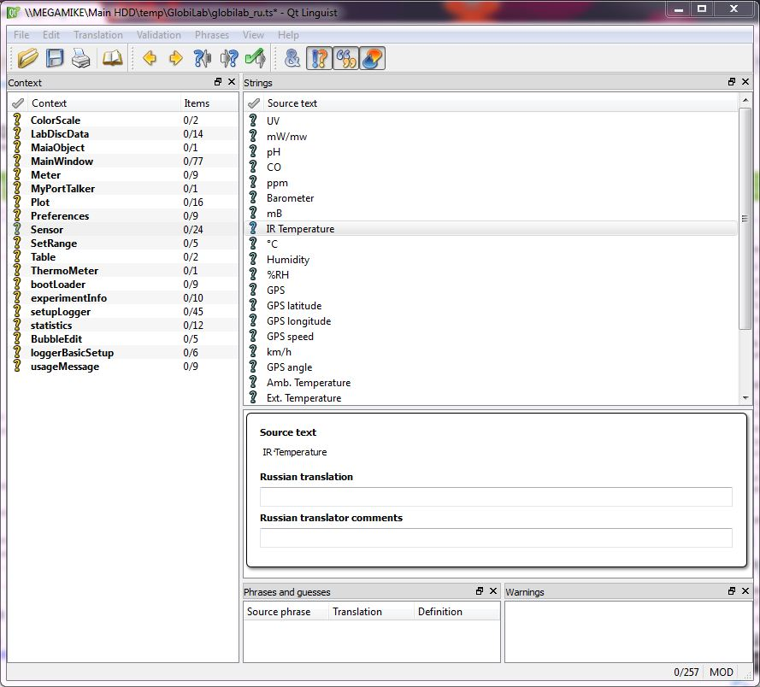
6. save the translation
5. a place to write any comment or question. (not required usually, use only if needed)
1. Open the translation file
4. write here the translation.
a short cut for the going directly to the next string: <CTRL><RETURN>
3. Click on a phrase to translate. It will be displayed below ("Source text").
2. Click on a category, All the strings sharing this context will appear in the right panel ("Strings").

